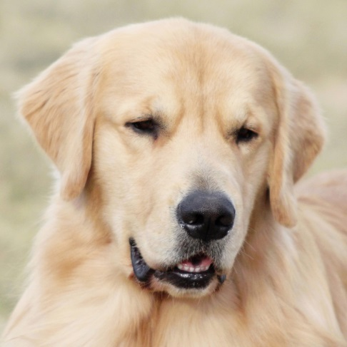
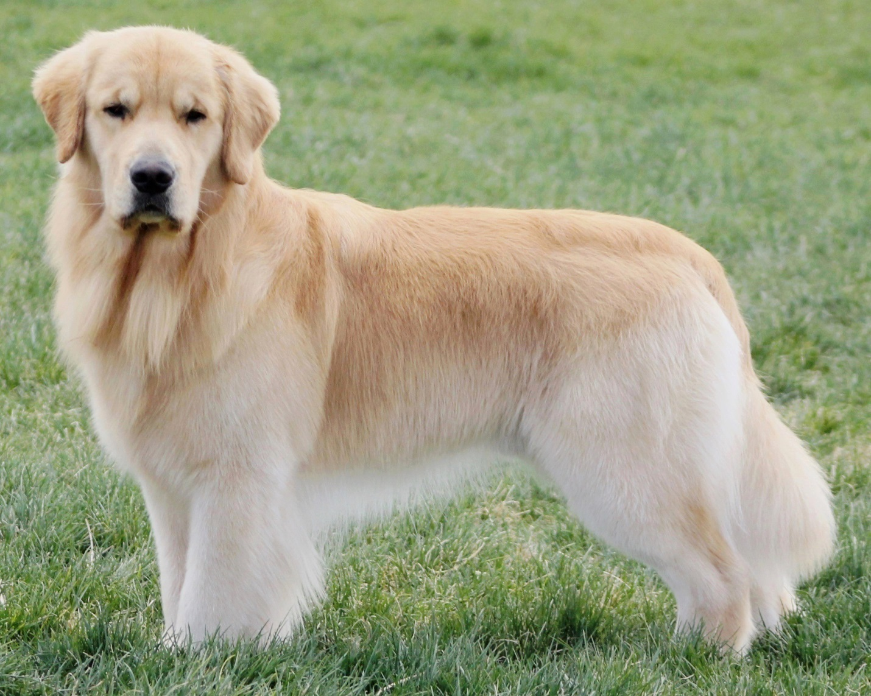
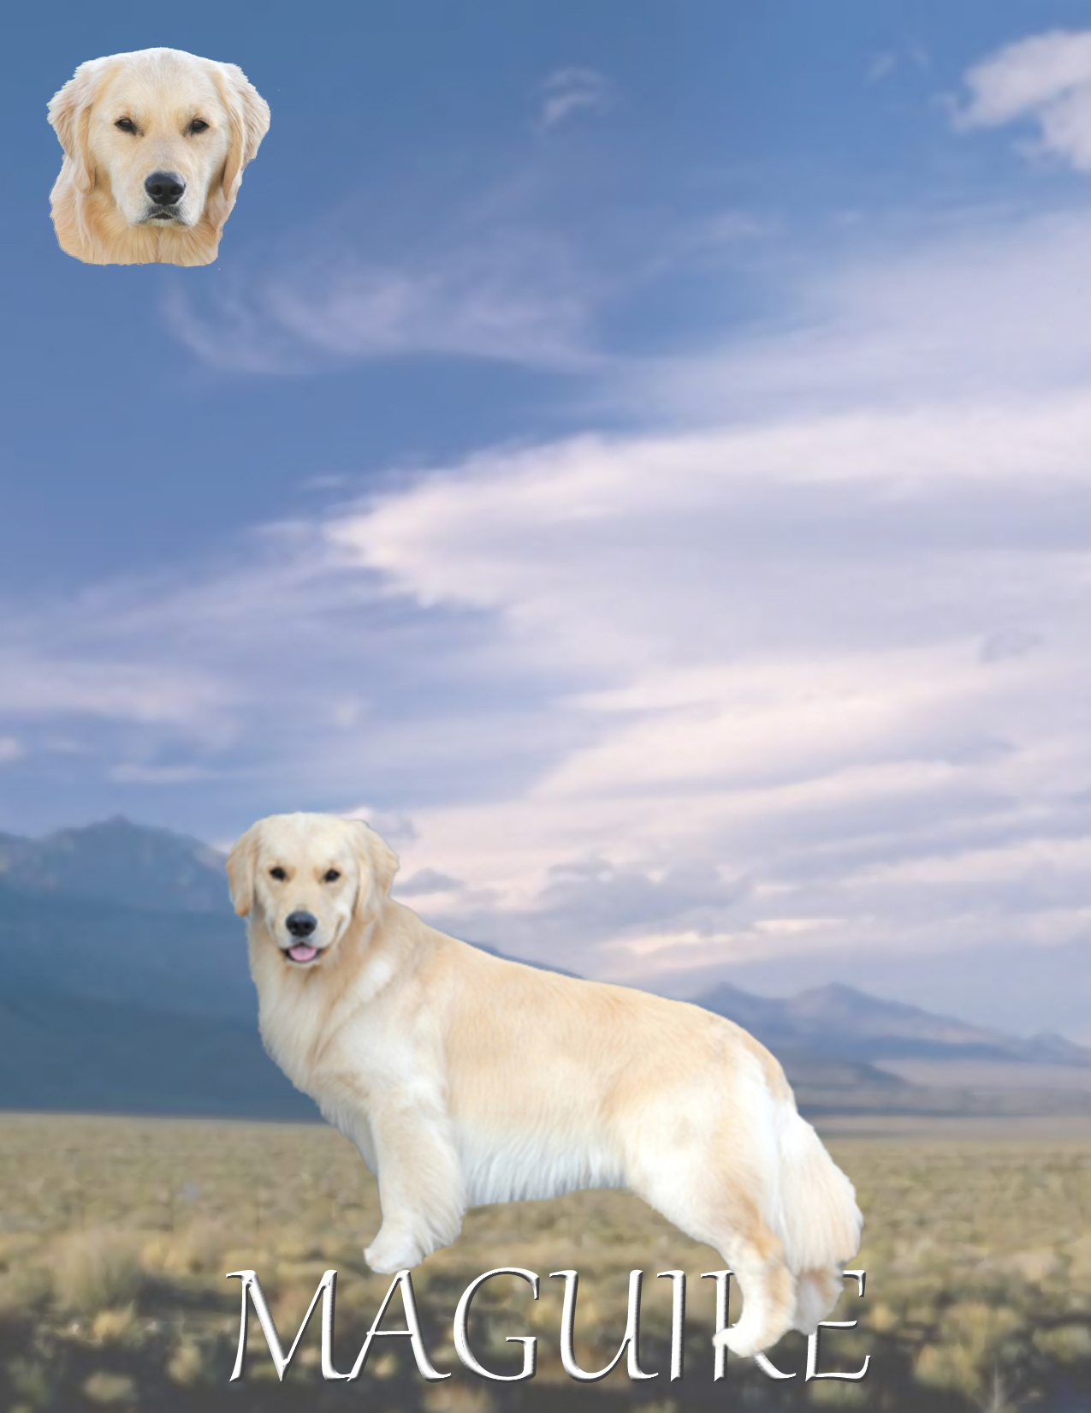
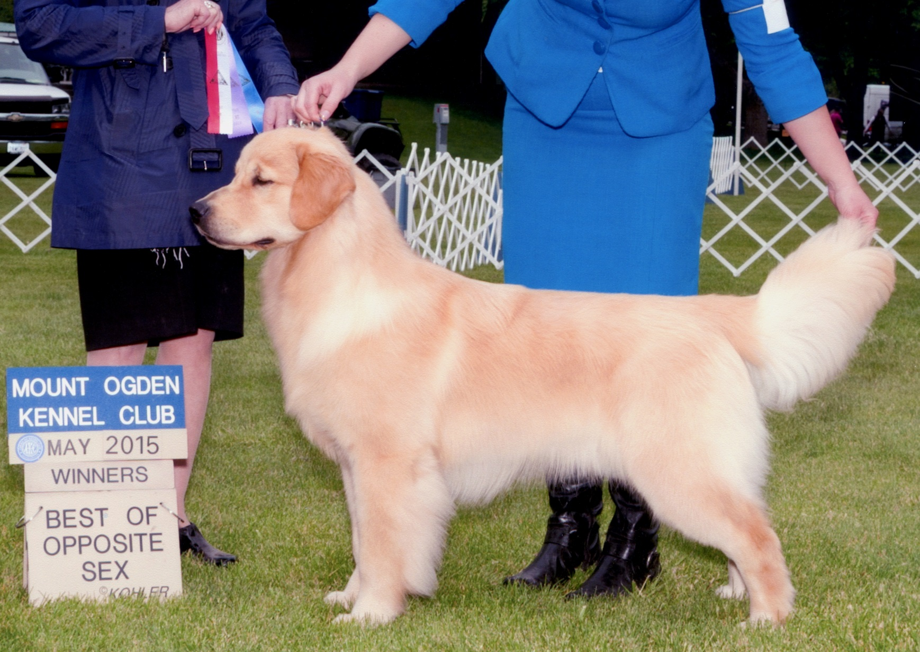
Wyatt stands at 23.5” at the withers and weighs 74 lbs.. He sports a straight double coat with correct texture and cream furnishings. He has a beautiful, masculine head .
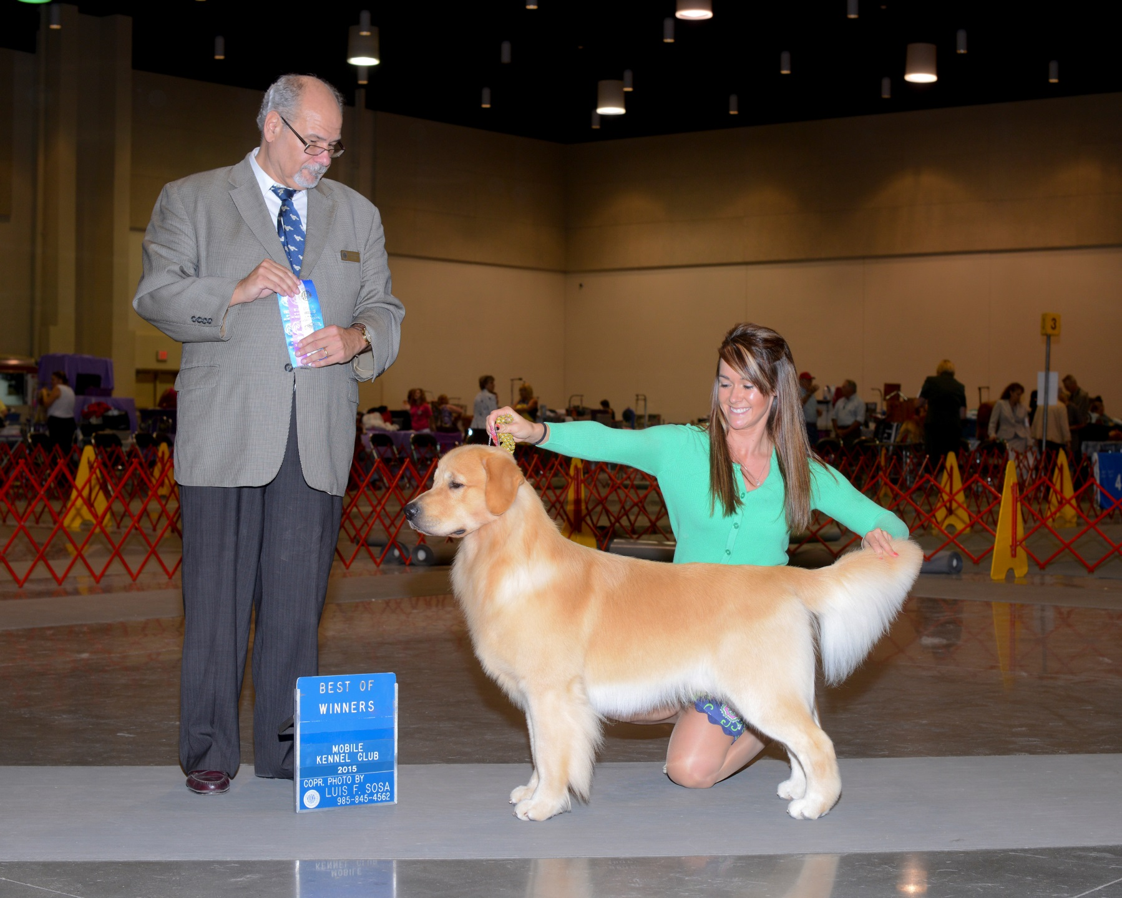
Wyatt has a beautiful expression. He has a short back with well laid back shoulders and good rear angles to match.. His movement is effortless and he is clean coming and going with big reach and drive .

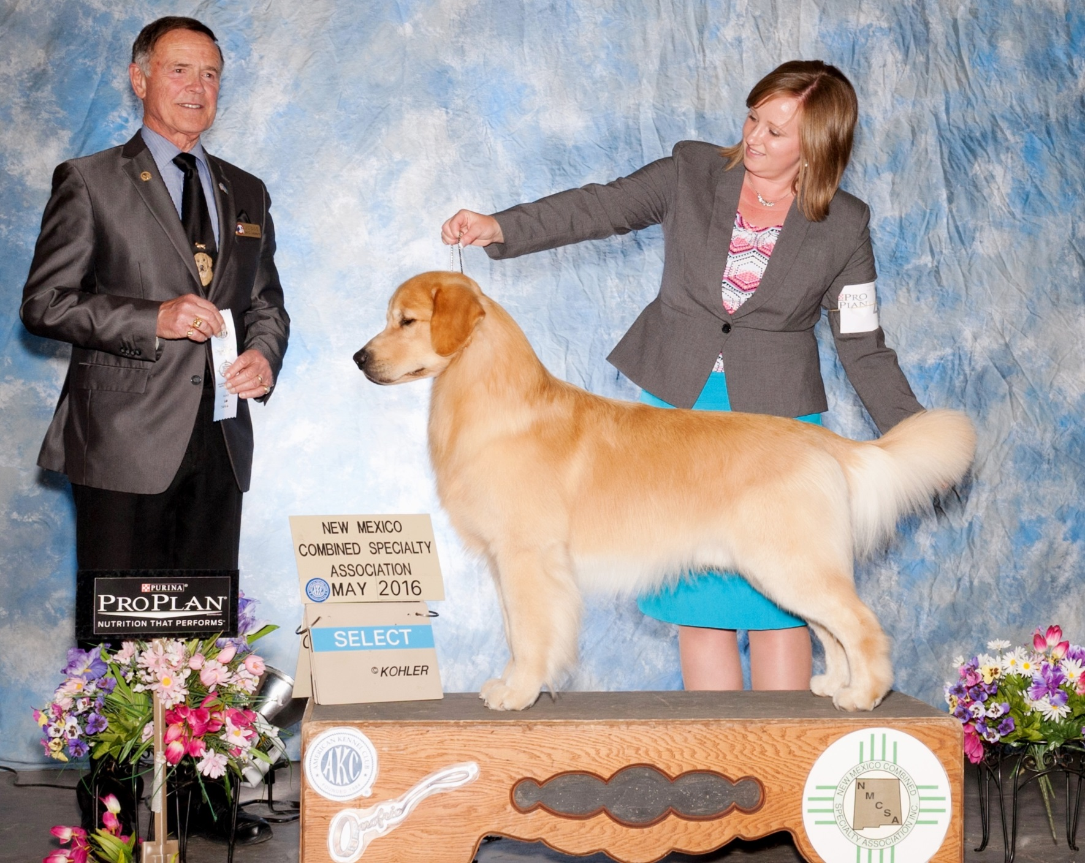
Wyatt has a correct scissors bite with full dentition. His temperament is playful, sweet and he always wants to please. He has great prey drive and will retrieve almost anything.

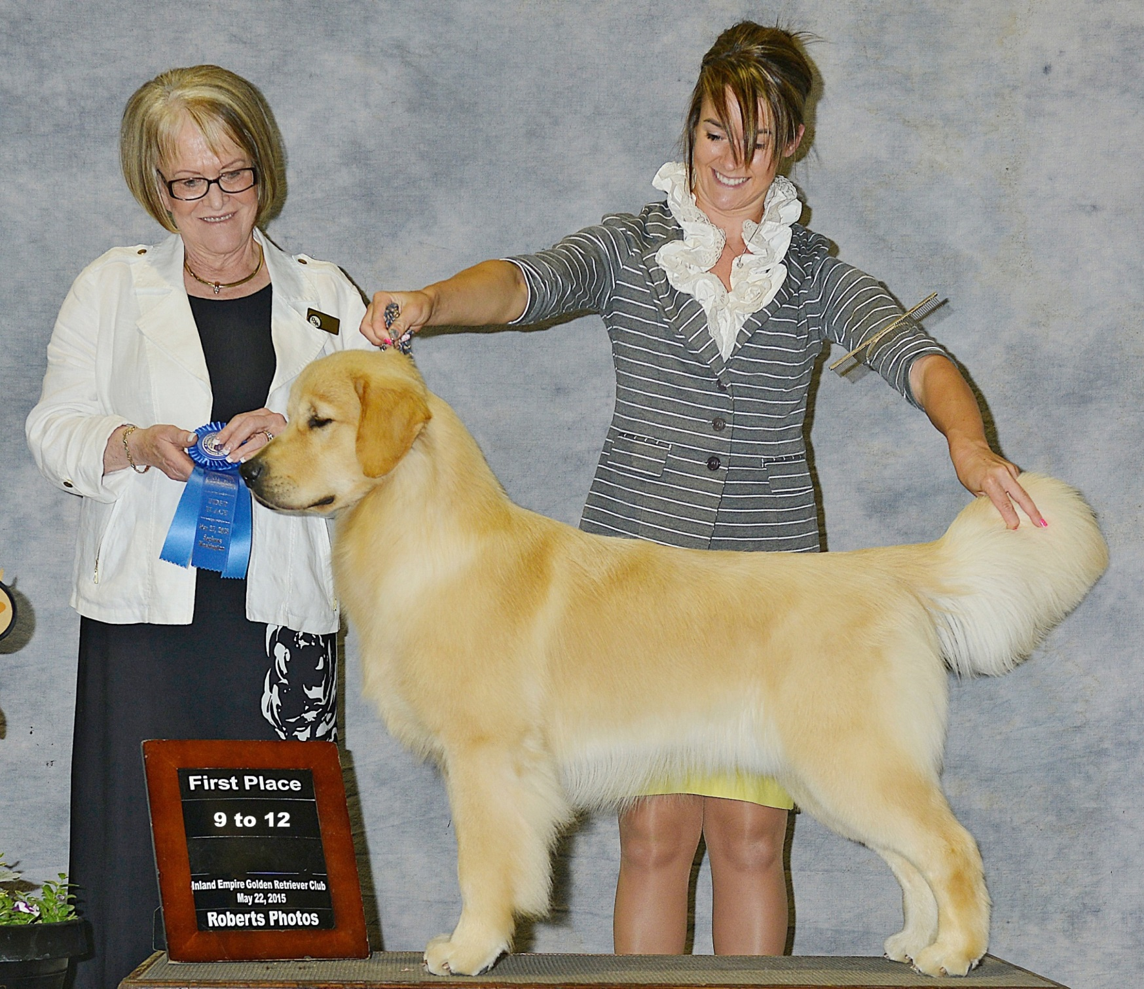
Wyatt has a lovely topline and neck into shoulder blend with plenty of forechest.

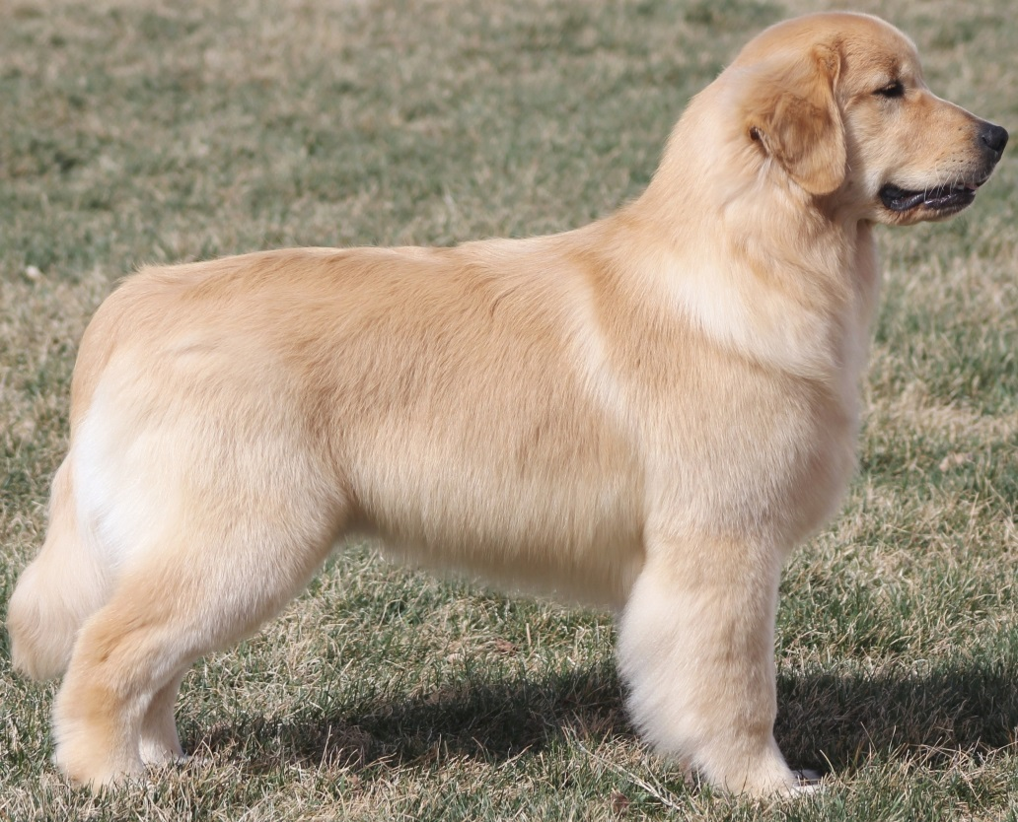
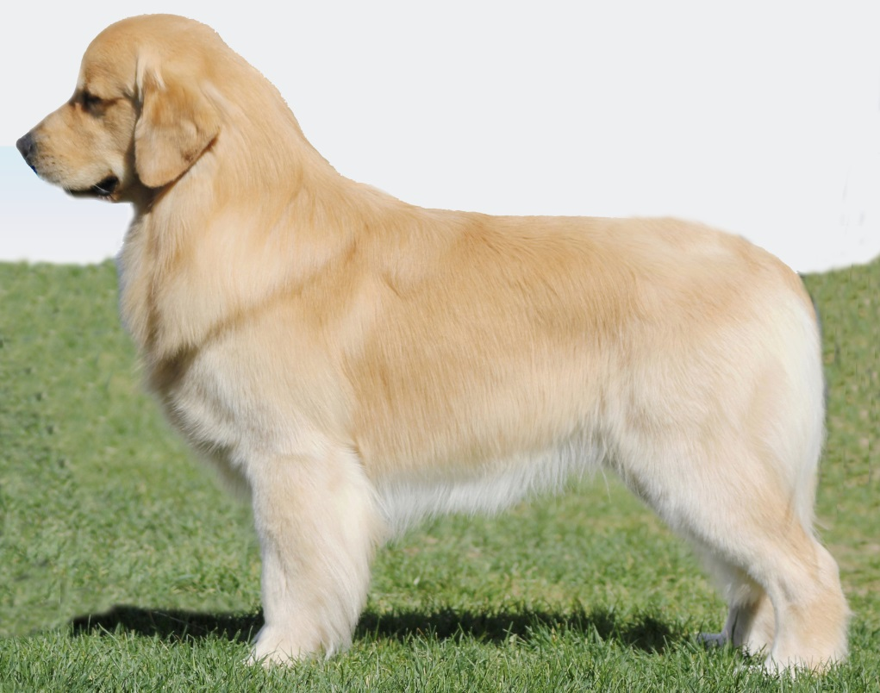
Wyatt loves the show ring but feels right at home in the field as well. He excels at everything he does.

Wyatt loves everyone and gets along with dogs, bitches and puppies . He is always eager to please.

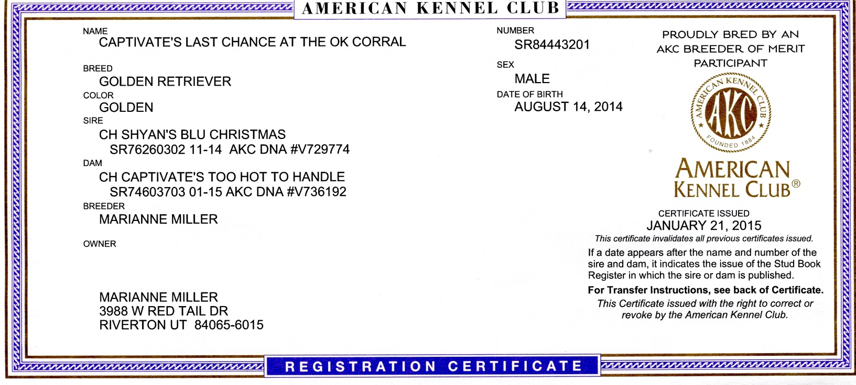
APPENDIX: REGISTRATION AND HEALTH CERTIFICATIONS

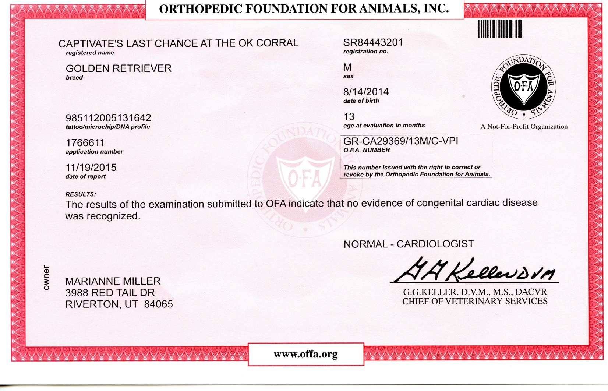
APPENDIX: REGISTRATION AND HEALTH CERTIFICATIONS
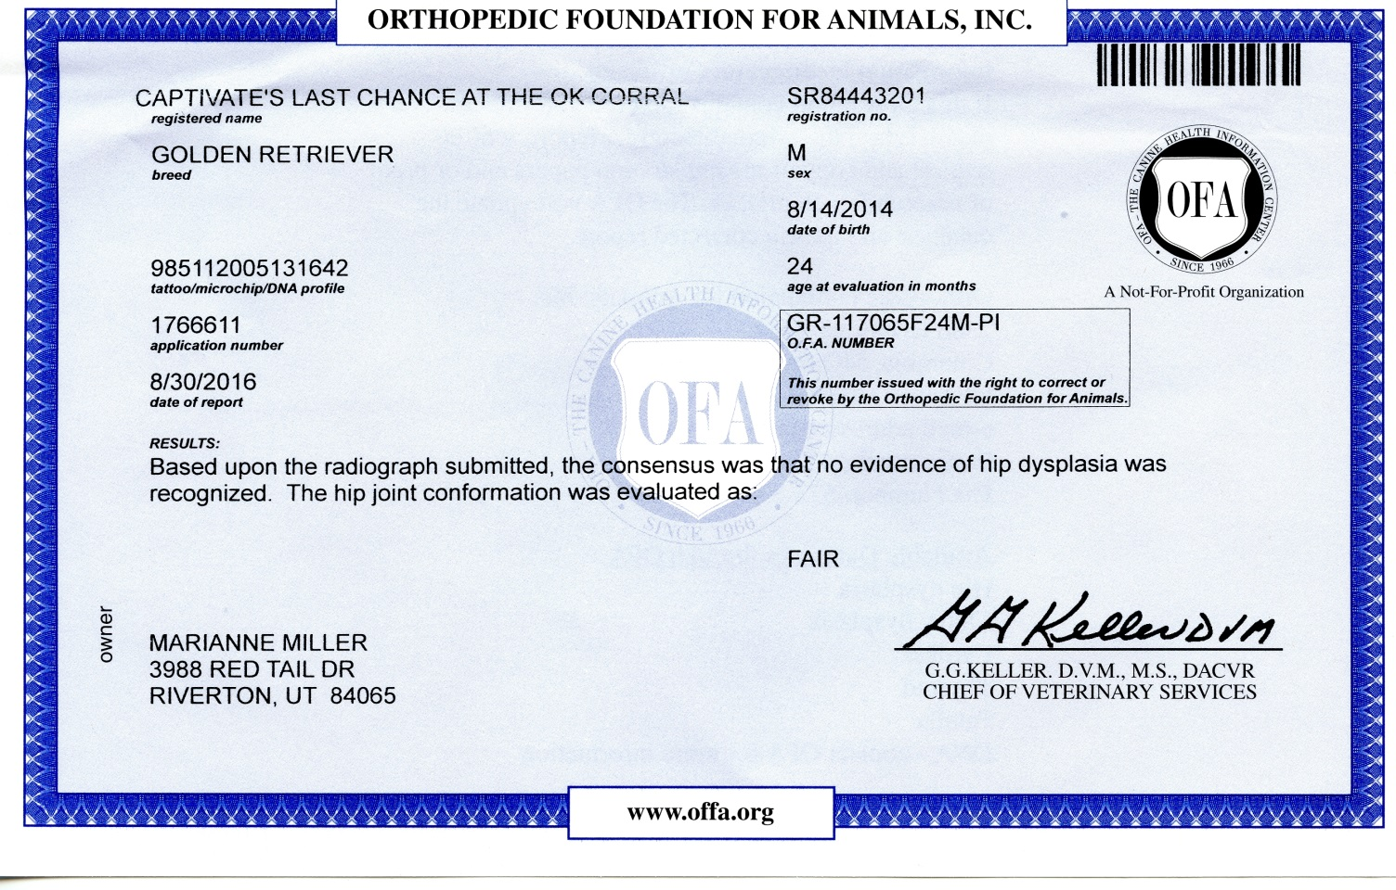
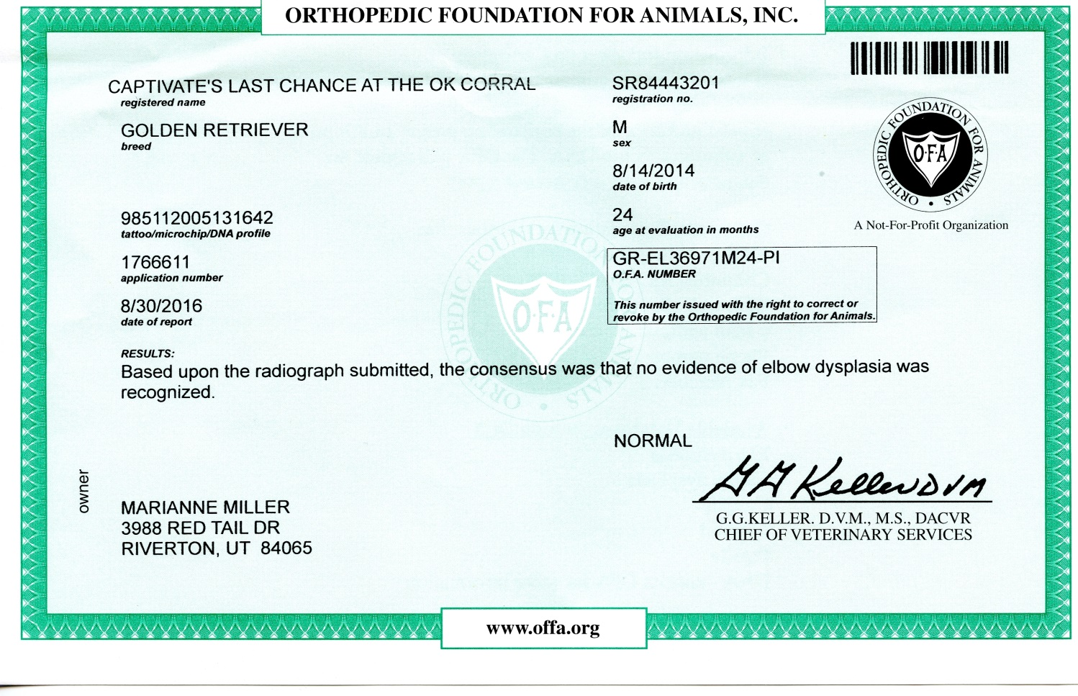
APPENDIX: REGISTRATION AND HEALTH CERTIFICATIONS
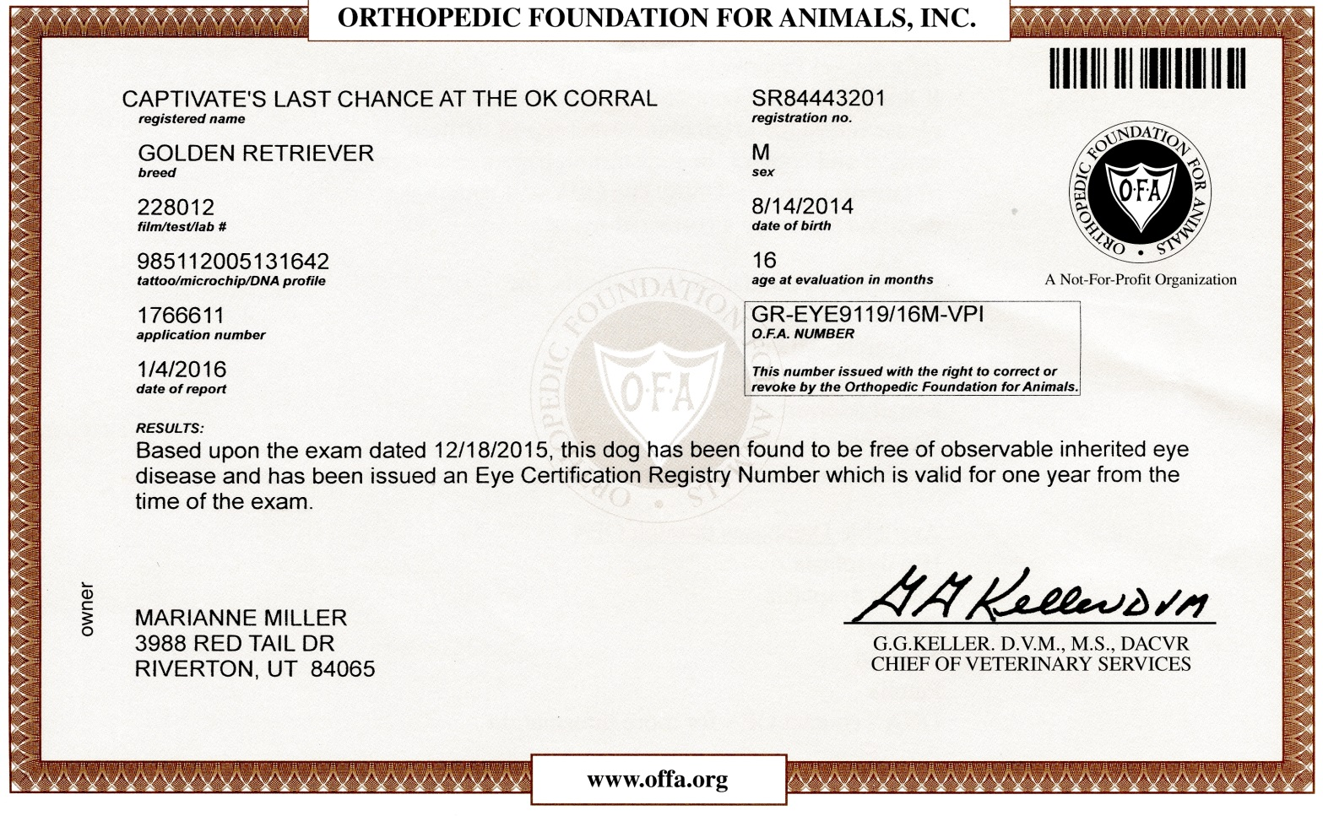
APPENDIX: REGISTRATION AND HEALTH CERTIFICATIONS
APPENDIX: AKC GRAND CHAMPION
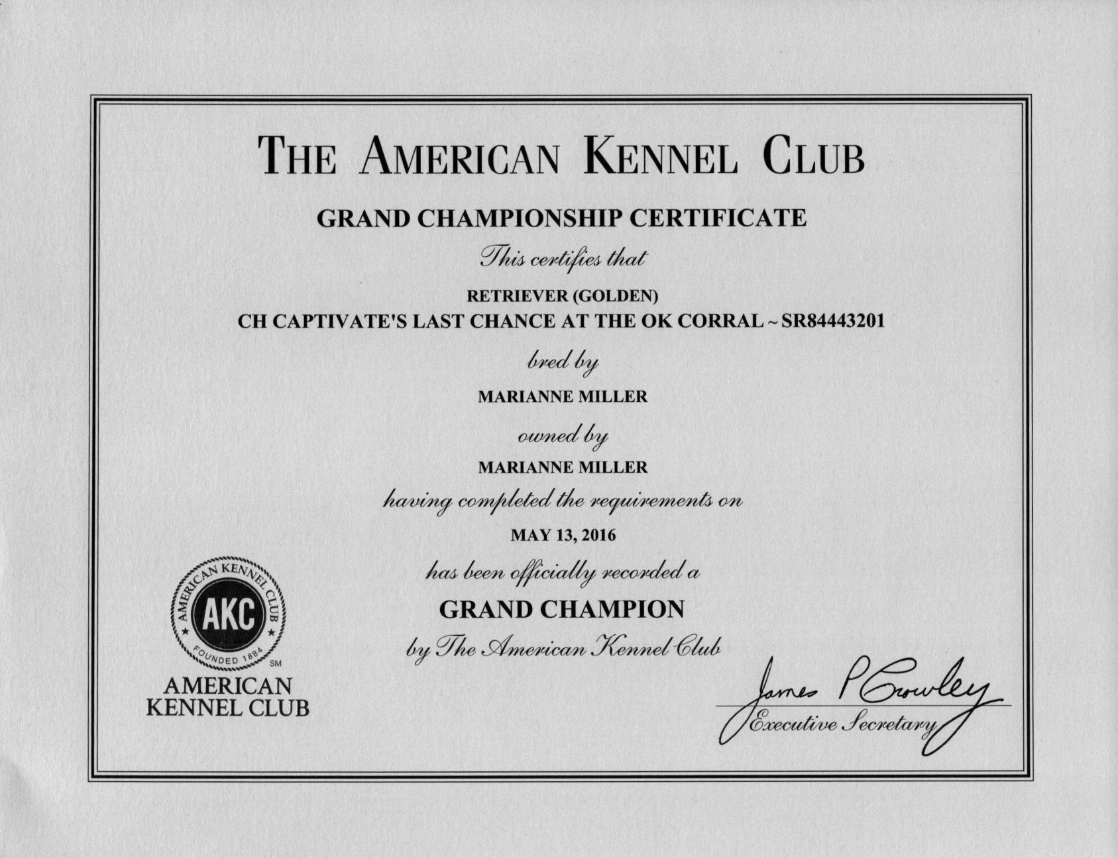
APPENDIX: 5 GENERATION PEDIGREE

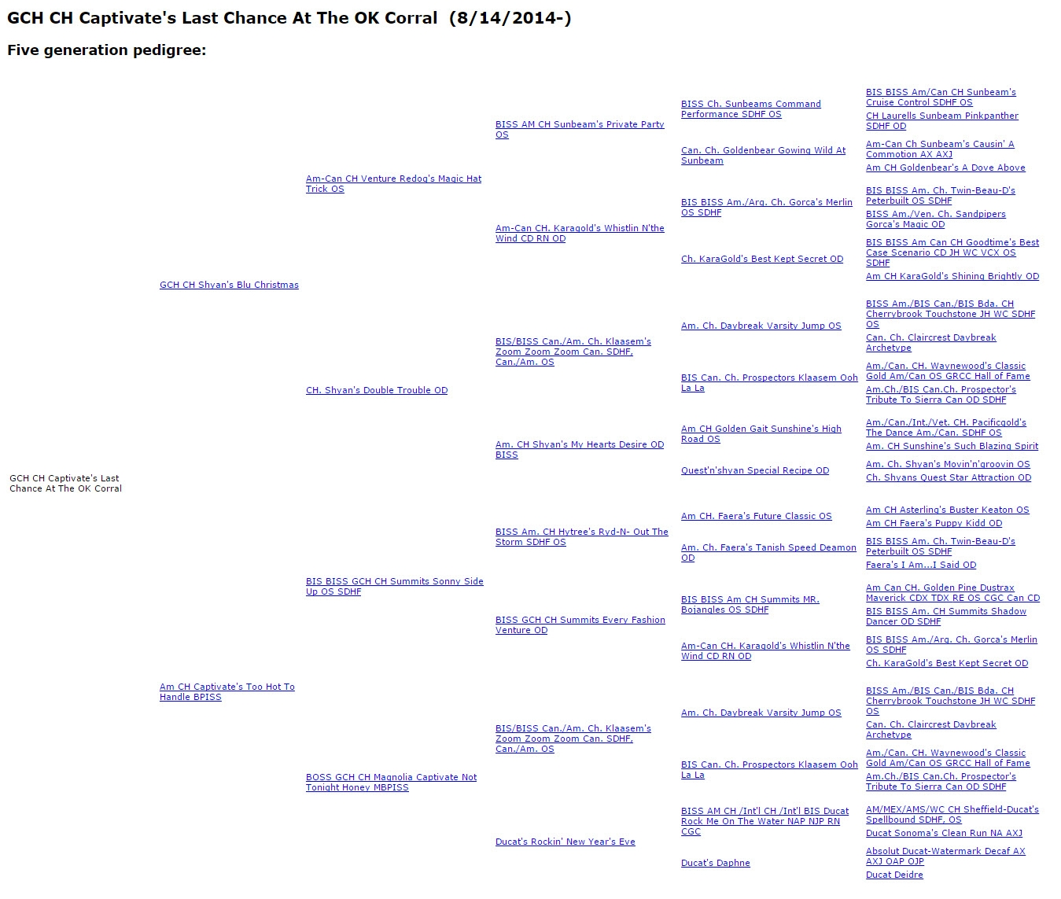
http://www.k9data.com/fivegen.asp?ID=634101

Captivate Goldens
Marianne and Larry Miller

3988 Red Tail Drive
Riverton, UT 84065
(801) 368-1400

GCH CH Captivate’s Last Chance At The OK Corral

SR84443201

Stud Agreement

Bitch’s Registered Name: _______________________________________________
AKC Number: _______________________________________
Microchip/Tattoo Number: _____________________________

Under the terms of this agreement, Marianne Miller and Larry Miller, owners of the above Stud dog and _________________________________, Owner (s) of the Bitch agree as follows.

The Stud fee shall be One Thousand Two Hundred Dollars ($1,200.00). A fee of Two Hundred Dollars ($200.00) (non-refundable breeding fee) is due at the time of the breeding and the balance of One Thousand Dollars ($1,000.00) is due within two weeks following the whelping of the litter or when the Stud dog owner signs the litter registration. A litter is defined as three or more puppies. The Stud dog owner will not sign litter registration until the entire amount of Stud Service is paid, including any reimbursement of any breeding related expenses.

If two puppies or less are born, the Stud fee will be Two Hundred Fifty Dollars ($250.00) per puppy (over and above the non-refundable breeding fee) and there will be no further obligation on the part of the Bitch owner or Stud dog owner/agent.
If NO litter results from this breeding no additional payment will be due to the Stud dog owner and there will be no further obligation on the part of the Bitch owner or the Stud dog owner/agent.

The owner of the Bitch is responsible for the health of the Bitch and will provide the Stud dog owner with a copy of the following:
- A Signed copy of the Stud contract
- A 3-generation pedigree
- Copy of the AKC registration
- OFA hip and elbow certification by OFA
- CERF and current ophthalmologist report done within the last year
- OFA cardiac certification or Cardiac report from a board certified cardiologist
- Brucellosis test report within the last 30 days
- Current immunization record
- Photograph

Brucellosis testing is not required when using fresh extended semen procedures.
All expenses related to collecting, shipping and inseminating the Bitch are the responsibility of the Bitch owner.

Breeding will occur as soon as the Bitch will allow and then subsequently every 36 – 48 hours for as long as the Bitch will stand, unless otherwise instructed by the Bitch owner.

Any Veterinary fees related to the Bitch’s care (smears, artificial insemination, health certificate, etc.) and maintenance is the responsibility of the Bitch owner. Should the Bitch become ill, the owner of the Bitch shall authorize all immediate and necessary care and will be responsible for any and all veterinary charges.

The Bitch owner holds the Stud dog owners harmless for any and all illness/injury/death, which may occur in the course of this contract (during or as a result of this breeding). Under no circumstances are the Stud dog owners responsible legally or financially for any illness/injury/death which may occur during or after this breeding.

Uncontrollable or destructive behavior will be cause to return the Bitch to her owner.

The owner of the Bitch is responsible for transportation of the Bitch to and from the Stud dog owner’s residence. If the Bitch is shipped for breeding, all expenses for shipping to Salt Lake City International Airport will be paid in advance by the Bitch owner.

Ten days board is included in the Stud Service Fee. If the Bitch is maintained at the Stud Dog’s property more than ten days the Bitch owner agrees to pay an additional Fifteen Dollars ($15.00) per day.

The Bitch owner agrees none of the puppies from this service shall be sold to a pet shop, agent or broker. Bitch owner agrees to sell show puppies from this breeding with a contract forbidding the sale of the dog to a pet shop, agent or broker. The Bitch owner agrees that pets sold from this litter will be sold with Limited registration and spay/neuter contracts.

The Bitch owner will provide the names, addresses, phone numbers and AKC names and numbers of all puppy buyers to the Stud dog owner.

If the Bitch owner fails to fulfill the conditions of this contract, the Stud dog owner will have the right to pursue monetary damages of not less than Fifteen Thousand Dollars ($15,000.00) and reasonable attorney’s fees.

AFTER READING THE ABOVE TERMS AND CONDITIONS, WE FIND THEM MUTUALLY AGREEABLE AND ACCEPTABLE.

______________________________________________ DATE____________________
Owner of the Stud dog

______________________________________________DATE____________________
Owner of the Bitch (signature)

Please print:

________________________________________________________________________
Owner(s) of the Bitch

________________________________________________________________________
Address

_____________________________________
Phone

